Genome Rearrangement with Gene Families
David Sankoff
Bioinformatics, Vol. 15, No. 11, pp. 909-917, 1999
Abstract
In this paper, we formulate a general version of the genome rearrangement problem where each gene may be present in a number of copies, The idea is to delete all but one member of each gene family-its exemplar-, so as to minimize some rearrangement distance between the two reduced genomes.
- The Essential Problem
- Definition:
  - : an alphabet
  - G and H: two strings(genome) of signed symbols from
  - 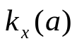: the number of occurrences of symbol in genome
X, assume that all 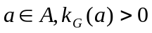 and 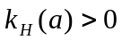
  - gene family: all occurrences of the symbol in both
genomes
  - g and h: we call these exemplar string ,which are constructed
by deleting all but one occurrence of each family
  - singleton: a gene is the only members of its family in a
genome
  - single-pair family: a gene family consists of two singletons,
one in each genome
- Problem:
In each genome, we try to delete all but one member of each gene family -its exemplar- in each of the two genomes being compared, so as to minimize some rearrangement distance between the two reduced genomes thus derived.
- The Algorithm
- Input : the genomes G and H
- Output: the exemplar string g and h, and exemplar distance
- Procedure:
  - label gene families from 1 to n=|| in order of increasing
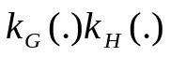. From partial exemplar strings from genes in the s single-pair families ,ordered as in G and H.
in all families, all pair of genes are initially 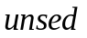, 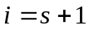, current_distance=
  - do a while loop, condition: 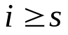
  - in the while loop:
      - First we check that if there remain unused pairs in the
-th family, if exist, all pairs in the -th family regain unused status and set =-1, otherwise go to step I.
I. Check that if all the pairs in the -th family are unused or not, if it is true, then evaluate the distance between the partial exemplar string
II. Expand the partial exemplar string by inserting the un used pair with minimal . This pair acquires “used” status
III. Check that if 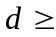current_distance or not, if it is true, we set all pairs in the -th family regain unused status, =-1, else set =+1
      - Check that if 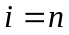 or not, if it is true, we set that current_distance= and =-1
      - 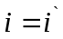
4. output exemplar string and

Created by: Hung-Wei Huang
Date: Apr. 2, 2003

